**OC EXPERIMENT LAB 7**

**TITLE**: Writing 8051 assembly language program of basic arithmetic operations

**NAME:** Yash Gupta

**ROLL NO**: S20200010234

**OBSERVATION**: In this lab I learnt how to write 8051 assembly language programs in keil software of basic arithmetic operations using different addressing modes.

Q1. Write an 8051-assembly language program to perform the following operations

- addition

- subtraction

- division

- multiplication

between two numbers using the concept of different addressing modes

and also illustrates the flags (AC, CY, OV, PF).

PROGRAM:

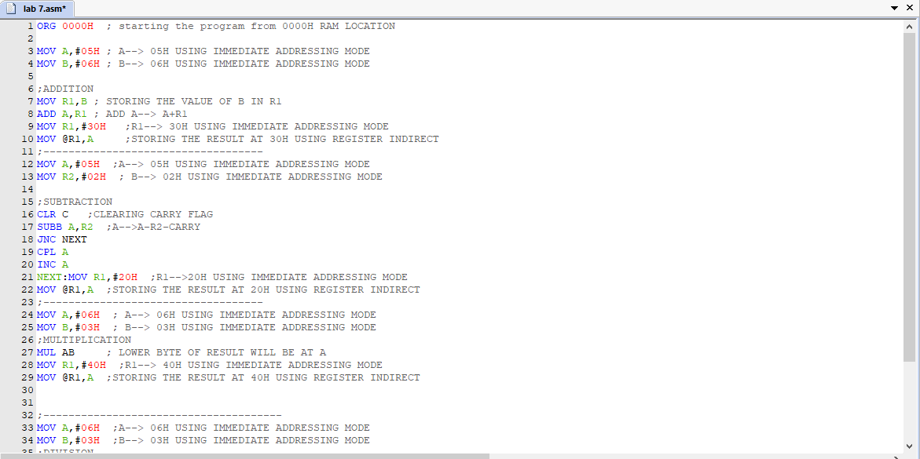

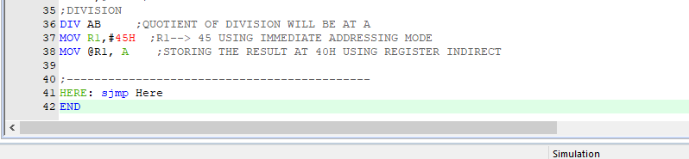

EMULATING:

After addition:

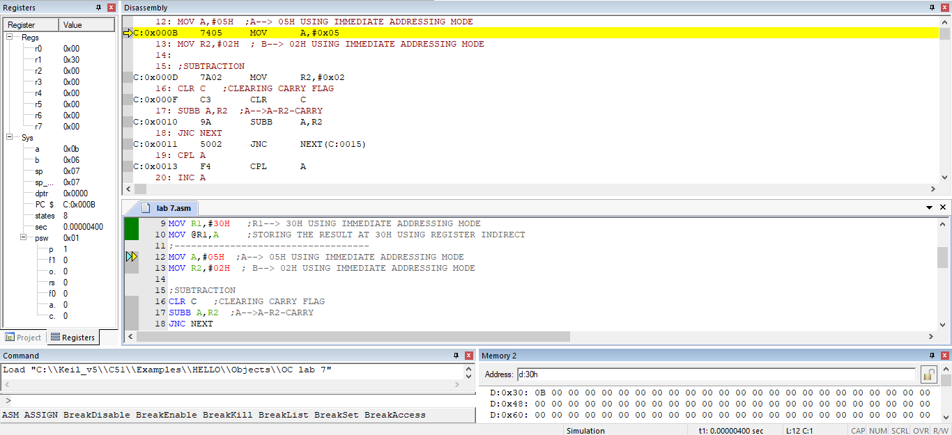

After subtraction:

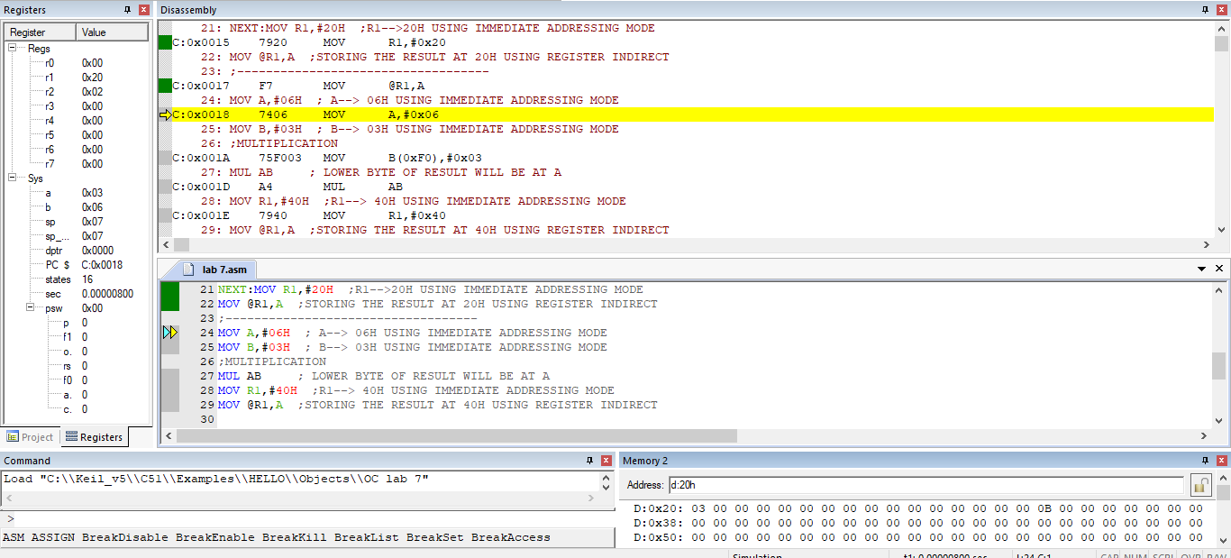

After multiplication:

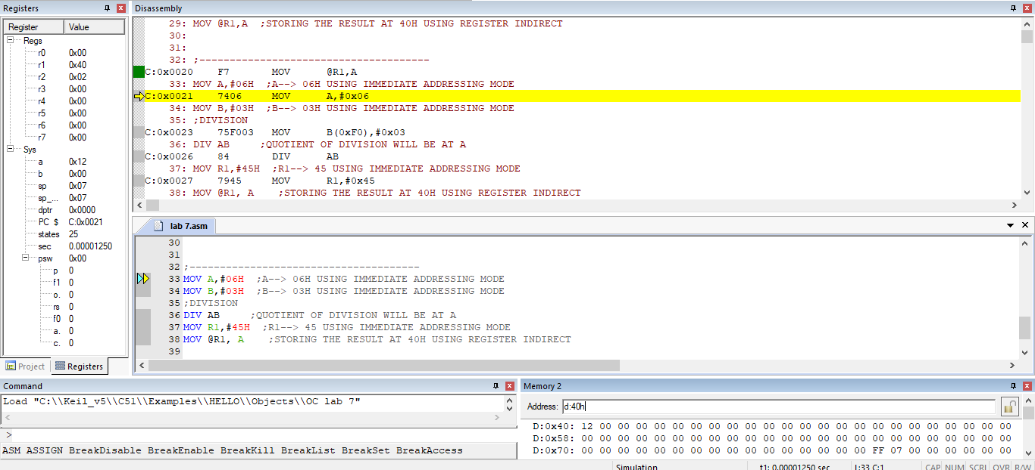

After division:

